Mandeep Kaur

Tender AI Assistant
Detailed System Design Document

Table of Contents
Tender-AI System Architecture & Project Structure 3
Sample Input: 4
Sample Output: 4
PART 1 — HISTORICAL DATA INGESTION 5
1. Objective of Historical Ingestion 5
2. What Happens During Ingestion 5
PART 2 — GRAPH-BASED RUNTIME FLOW 9
1. Runtime Objective 9
Step-by-Step Runtime Logic 10
1. Domain Classification 10
1.1 Rule-Based Classification 10
1.2 LLM-Based Classification 10
1.3 Hybrid Decision 10
1.4 Domain Confidence 11
2. Risk Detection 11
3. Retrieval 11
4. Match Strength & Routing 11
5. Answer Generation 12
5.1 HISTORICAL_GUIDED 12
5.2 TEMPLATE_SAFE 12
6. Softening Layer 12
7. Guardrails 13
8. Initial Confidence Calculation 13
9. Verification 13
10. Overclaim Detection 13
11. Confidence Calibration 14
12. Flags & Escalation 14
13. Audit Logging 14
14. Generated Memory (Long-Term Learning) 15
15. Caching 15
16. Reliability & Error Handling 15
17. Hallucination Prevention Strategy 16
18. Short-Term vs Long-Term Memory 16
Future Enhancements 17

Tender-AI System Architecture & Project Structure
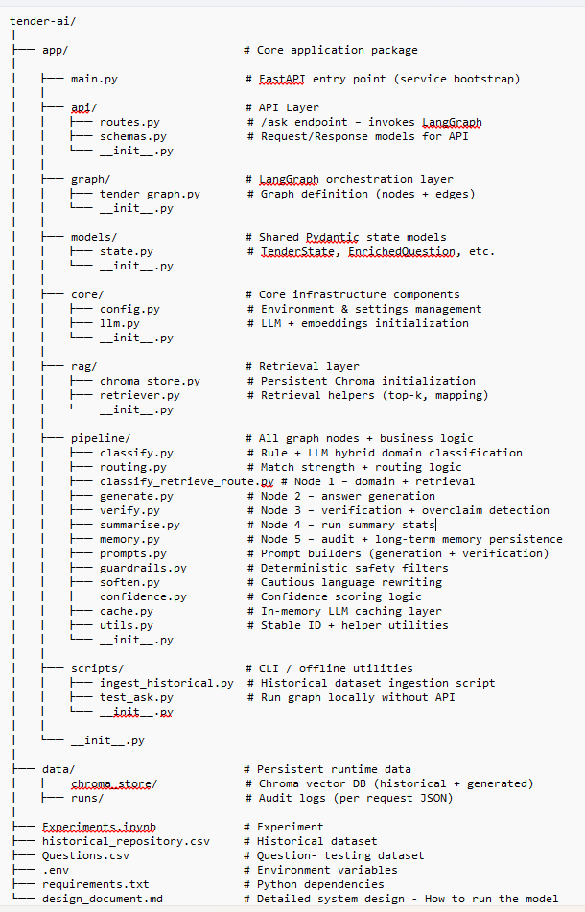

- Sample Input Data: Questions.csv ( Used Json to test my model)
- Historical dataset: historical_repository.csv
- Run Command - uvicorn app.main:app --reload
- response_1772512095413.json - Sample Output

Sample Input:
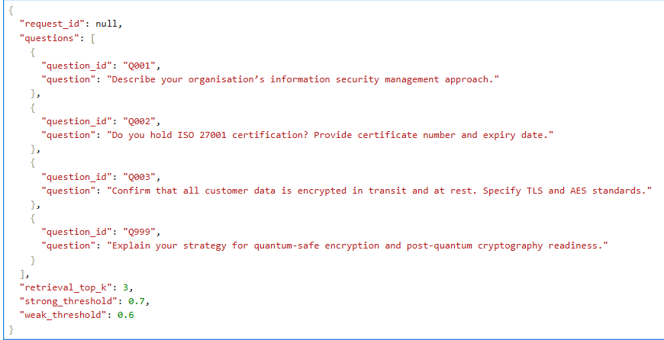

Sample Output:
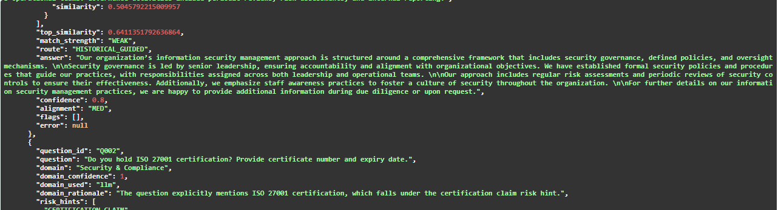
- data/runs/ - check the result of each run

PART 1 — HISTORICAL DATA INGESTION

Objective of Historical Ingestion
The purpose of ingestion is to build a structured, persistent, domain-aware knowledge base from prior tender responses. This becomes the long-term organizational memory of the system.
The ingestion process ensures:
- Historical Q/A are embedded consistently
- Domain metadata is attached
- Stable identifiers prevent duplication
- Retrieval later returns both question and answer content
- The store persists across service restarts
- The system remains deterministic across runs
This is the foundation for retrieval-augmented generation (RAG).

What Happens During Ingestion
Step 1 — Data Normalization
Incoming data (Excel/CSV/DataFrame) is normalized into a consistent structure:
Each record contains:
- Source ID (tender reference)
- Domain (e.g., Security & Compliance)
- Question text
- Answer text
Empty or malformed entries are ignored to prevent embedding meaningless content.
This prevents noise in vector space.
Step 2 — Stable Identity Assignment
Each historical record is assigned a stable identifier derived from:
- Source ID
- Question
- Answer
This ensures:
- Re-ingestion does not create duplicates
- Records are deterministic
- Vector store integrity remains consistent
Without this step, multiple identical records would accumulate and bias retrieval.
Step 3 — Metadata Enrichment
Each record is stored with structured metadata including:
- source_id
- domain
- question_id
- historical_question
- historical_answer
- kind = historical
This metadata enables:
- Domain-consistent retrieval (future enhancement)
- Evidence pack construction
- Explainability
- Audit traceability
Metadata is critical because retrieval returns both content and structured fields.
Step 4 — Embedding Generation
Each historical Q/A pair is converted into a vector representation using a consistent embedding model.
This transforms natural language into semantic vector space.
Important design considerations:
- The same embedding model must be used at retrieval time.
- Changing embedding models requires reindexing.
- Embedding consistency preserves similarity meaning.
Step 5 — Persistent Storage (Chroma)
Vectors are stored in a persistent directory.
Key properties:
- Survives service restarts
- Supports similarity search
- Allows top-K retrieval
- Is separated from generated memory
Two collections exist:
- historical (trusted knowledge)
- generated (curated AI responses)
This separation prevents self-poisoning.
3. Historical Data Governance
Trust Model
The system assumes:
- Historical data is curated
- It reflects validated past responses
However, governance enhancements include:
- Source trust scoring
- Blacklisting bad records
- Versioned collections
- Periodic manual audit
4. Risks in Historical Ingestion
Risk: Schema Drift
If metadata structure changes, retrieval may silently break.
Mitigation:
- Fixed metadata contract
- Schema version tagging
- Store validation tests
Risk: Duplicate Records
Mitigation:
- Stable ID hashing
Risk: Embedding Drift
If embedding model changes, similarity thresholds become meaningless.
Mitigation:
- Model version control
- Full rebuild upon embedding change
5. Historical Store as Long-Term Memory
Historical store represents:
- Organizational knowledge
- Previously approved answers
- Domain-aligned examples
It does not:
- Automatically learn from generated responses
- Accept unverified outputs
Generated memory is gated separately.

PART 2 — GRAPH-BASED RUNTIME FLOW

1. Runtime Objective
Given a new tender request, the system must:
- Understand the domain
- Detect risk
- Retrieve relevant historical context
- Generate a grounded answer
- Avoid hallucinations
- Verify alignment with evidence
- Flag risky or unsupported claims
- Calculate operational confidence
- Persist audit trail
- Optionally store validated outputs
All while ensuring:
- System resilience
- Graceful degradation
- SME escalation capability
Runtime Processing Flow (High-Level)
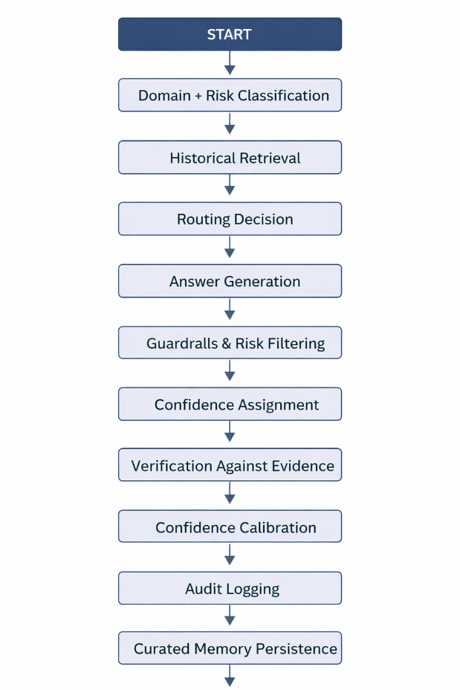

Step-by-Step Runtime Logic

1. Domain Classification
Each incoming question is classified using a hybrid model:

1.1 Rule-Based Classification
The system evaluates domain keywords.
Domains include examples such as:
- Security & Compliance
- Operations & Support
- Finance & Procurement
- HR & Workforce
- General
Each domain has associated keyword patterns.
Example:
- "ISO", "PCI", "GDPR" → Security
- "uptime", "SLA" → Operations
Rules assign:
- Domain
- Confidence score
- Rationale
- Risk hints
If keyword signal is weak or ambiguous, confidence remains low.

1.2 LLM-Based Classification
If rules are weak or ambiguous:
- The LLM classifies domain
- Detects risk hints from allowed list:
  - CERTIFICATION_CLAIM
  - SLA_PROMISE
  - LEGAL_COMPLIANCE
- Returns structured output

1.3 Hybrid Decision
The system selects:
- Rule decision if strong
- LLM decision if rules weak
Risk hints are merged (union of both sources).

1.4 Domain Confidence
Domain confidence reflects classification strength.
It is:
- Not a probability
- Not calibrated
- An operational signal
Confidence influences downstream behavior but does not directly alter routing.

2. Risk Detection
Risk hints are identified early.
Risk categories:
- CERTIFICATION_CLAIM
- SLA_PROMISE
- LEGAL_COMPLIANCE
These affect:
- Tone of answer
- Guardrails
- SME escalation likelihood
- Confidence penalties
Risk detection is additive.
Missing risk is more dangerous than false positive.

3. Retrieval
The system performs vector similarity search in the historical collection.
For each question:
- Retrieve top-K matches
- Extract similarity scores
- Capture historical question/answer pairs

4. Match Strength & Routing
Similarity score determines match strength:
- STRONG ≥ strong_threshold
- WEAK ≥ weak_threshold
- NONE < weak_threshold
Routing logic:
- STRONG → HISTORICAL_GUIDED
- WEAK → HISTORICAL_GUIDED (cautious)
- NONE → TEMPLATE_SAFE
Routing directly impacts hallucination risk.

5. Answer Generation

5.1 HISTORICAL_GUIDED
Prompt includes:
- Original question
- Evidence pack (top matches)
- Instruction: do not invent unsupported claims
The model is grounded in prior examples.

5.2 TEMPLATE_SAFE
If no strong evidence:
- Use domain-aligned structured template
- Avoid specifics
- Use conditional language
Example phrasing:
- “Details available upon request”
- “Subject to due diligence”
- “May include…”
This reduces fabrication risk.

6. Softening Layer
Applied when:
- No strong evidence
- Template route
Purpose:
- Convert assertive claims to cautious phrasing
- Remove guarantees
- Prevent false commitments
This prevents hallucinated certainty.

7. Guardrails
Deterministic filters detect:
- Numeric SLA guarantees
- Certification claims
- Specific cryptographic standards
- Unqualified compliance assertions
Guardrails:
- Add flags
- Lower alignment
- Reduce confidence
- Do not crash system

8. Initial Confidence Calculation
Confidence is based on:
- Retrieval similarity
- Match strength
- Risk flags
It represents:
Operational reliability score, not correctness probability.
No evidence → low confidence.
Strong evidence → moderate/high confidence.

9. Verification
Only runs when evidence exists.
Verifier checks:
- Does answer align with evidence?
- Does answer contradict evidence?
- Does answer introduce unsupported specifics?
Outputs:
- SUPPORTED
- PARTIALLY_SUPPORTED
- UNSUPPORTED
- CONTRADICTS_EVIDENCE

10. Overclaim Detection
Strict definition:
Overclaim only if answer asserts:
- “We are ISO 27001 certified”
- “We guarantee 99.9% uptime”
- “We use TLS 1.2 / AES-256” (if not in evidence)
Conditional phrases are NOT overclaims.
Overclaims reduce confidence.

11. Confidence Calibration
Confidence is recalculated by blending:
- Initial similarity-based confidence
- Verifier support score
Penalties applied for:
- PARTIALLY_SUPPORTED
- UNSUPPORTED
- CONTRADICTS_EVIDENCE
- OVERCLAIM
Clamped to safe bounds.

12. Flags & Escalation
Flags represent structured risk indicators:
Examples:
- HIGH_RISK
- NEEDS_EVIDENCE
- PARTIALLY_SUPPORTED_BY_EVIDENCE
- UNSUPPORTED_BY_EVIDENCE
- OVERCLAIM
- REQUIRES_SME_REVIEW
- NO_STRONG_HISTORICAL_MATCH
Flags are cumulative and explainable.
They allow:
- SME review gating
- Dashboard monitoring
- Confidence-based automation decisions

13. Audit Logging
Each run generates:
- Full request state
- Enriched questions
- Evidence packs
- Flags
- Final answers
- Confidence scores
Stored as JSON.
Purpose:
- Traceability
- Governance
- Debugging
- Regulatory defensibility

14. Generated Memory (Long-Term Learning)
Generated answers are stored only if:
- Verified sufficiently supported
- No critical flags
- Confidence above threshold
This prevents:
- Self-reinforcing hallucinations
- Memory poisoning
Generated store is separate from historical store.

15. Caching
In-memory caching applied to:
- Classification
- Verification
- Generation (optional)
- Softening
Purpose:
- Faster development cycles
- Reduced API calls
Cache does not affect correctness.

16. Reliability & Error Handling
System designed for resilience:
- Per-question try/catch
- Node-level error containment
- Fallback to rules if LLM fails
- Continue processing remaining questions
- Add error flags instead of crashing
Service never fails entire request due to one bad question.

17. Hallucination Prevention Strategy
Multi-layer defense:
- Retrieval grounding
- Domain-aware generation
- Cautious language templates
- Guardrails
- Verification layer
- Overclaim detection
- Confidence gating
- SME escalation
- Curated memory storage
No single layer is trusted alone.

18. Short-Term vs Long-Term Memory
Short-Term Memory
- Current run state
- Evidence pack
- Flags
- Confidence
- Audit context
Long-Term Memory
- Historical store (trusted)
- Generated store (curated)
Separation ensures stability.
System Philosophy
The system optimizes for:
- Compliance safety
- Non-fabrication
- Traceability
- SME oversight
- Risk transparency
It deliberately favors:
- Conservative answers
- Explicit uncertainty
- Confidence gating
Over:
- Aggressive automation
- Unverified specificity
- High recall hallucination

Future Enhancements
- Domain-consistent retrieval filtering
- Threshold calibration via evaluation set
- Deterministic claim-extraction model
- Sentence-level evidence alignment
- Redaction layer before persistence
- Generated-memory moderation workflow
- Batch inference optimization
- Async execution
- Confidence calibration curves
- Monitoring dashboards

